**Detailed circuit + draft layout with approximate dimensions**

**1.5.2022**

Neutral line

GRID

Manual switch

12 [Volt] power supply

Power supply



Precharge

Rotary Switch

Circuit breaker

15 [Volt] power supply

current measurement

15 [Volt] power supply



LCL





Voltage measurement.

CONTROLLER

GUASCH

**List of components**

Some of the components are not final and we haven’t decided on them, so we took models (most of them meets the requirements) for dimensions reference.

* **Guasch:**  
  we have the Guasch MTL-CBI0060F12IXHF (inverter). The real dimensions are:  
    
   Diagram, engineering drawing

  Description automatically generated
* **HV and Pre-charge:**
  + **HV:** the HV we draw or used in the model is using these relay dimensions:

<https://www.farnell.com/datasheets/2626616.pdf>

* + **Pre-charge:** we haven’t discussed the final model and HV+Precharge circuit with you, so the dimensions according to this (random – doesn’t meet our requirements) soft-start relay:  
    <https://www.gavazzionline.com/pdf/SSR_RGs1P_K.pdf>

* **LCL filter:**   
  using the thesis you sent us, we measured the plate’s and the capacitor (or -) dimensions and we calculated an approximate dimension.  
  + **C:**  
    by measuring component width divided by plate width the multiplied by the real size of get the component size.

Plate width (=232) component width (=19)

we get:

* **Width:**

Using the same way:

* **Height:**

* + **L:**  
    we get:
* **Width:**

Using the same way:

* **Height:**
* **Connection terminals for sensors:**  
  we haven’t chosen a terminal yet, although we found model that might be fit (meets the required current (20[A]) , voltage rating(750VDC/230VAC) and 3 poles – but we have to discuss it with you), so we used it for dimensions reference.  
  this is the data sheet:  
  <https://www.farnell.com/datasheets/2222574.pdf>

* **Auxiliary power supply:**we use a auxiliary power supply to provide auxiliary voltage to the LV part of the circuit.  
  although it’s not part of our design, we did pick a model that meets our requirements.

<https://www.farnell.com/datasheets/2724928.pdf>

Its dimensions are 22.5*90*100mm (W*H*D)

* + Single phase relay: we connect the power supply through a single phase relay.
* **Rotary switch:**

We use the rotary switch as a first connector to the grid and we use it as a manual security switch in case of an error so we can disconnect manually from the grid.

Here are some examples: <http://www.langirele.com/pdf/rotary-switch-lw30.pdf>

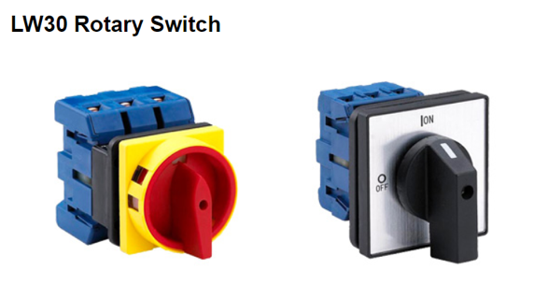

Typical dimension (W*H*D): 50*50*80mm

* **Power relay – single phase relay for power supply:**

we choose this model as relay for connecting the grid with the 15[V] power supply:  
<https://www.farnell.com/datasheets/2340607.pdf>

* **DC connection to Guasch:**we aren’t sure what kind of connections were looking for here, we saw so many options (different kind of connections) but we didn’t find anything that meets our requirements (the highest VDC rated we found is 24VDC).
* **AC connection:**  
  we aren’t sure if we should pick female/male cable gender.  
  we thought about the 3-phase AC male connection as the obvious choice, but we read in internet and we tried to find answers, the main thing that we noticed through the answers seeking was that especially when dealing with high voltage/current system that female connector is safer compared to the male connector.

**Layout**

we didn’t draw the layout draft on computer, we did by hand with taking 1:4 scale of the real size so we could try more than a placement and find the best and most efficient one.

We drew here blocks according to the 1:4 sizes.

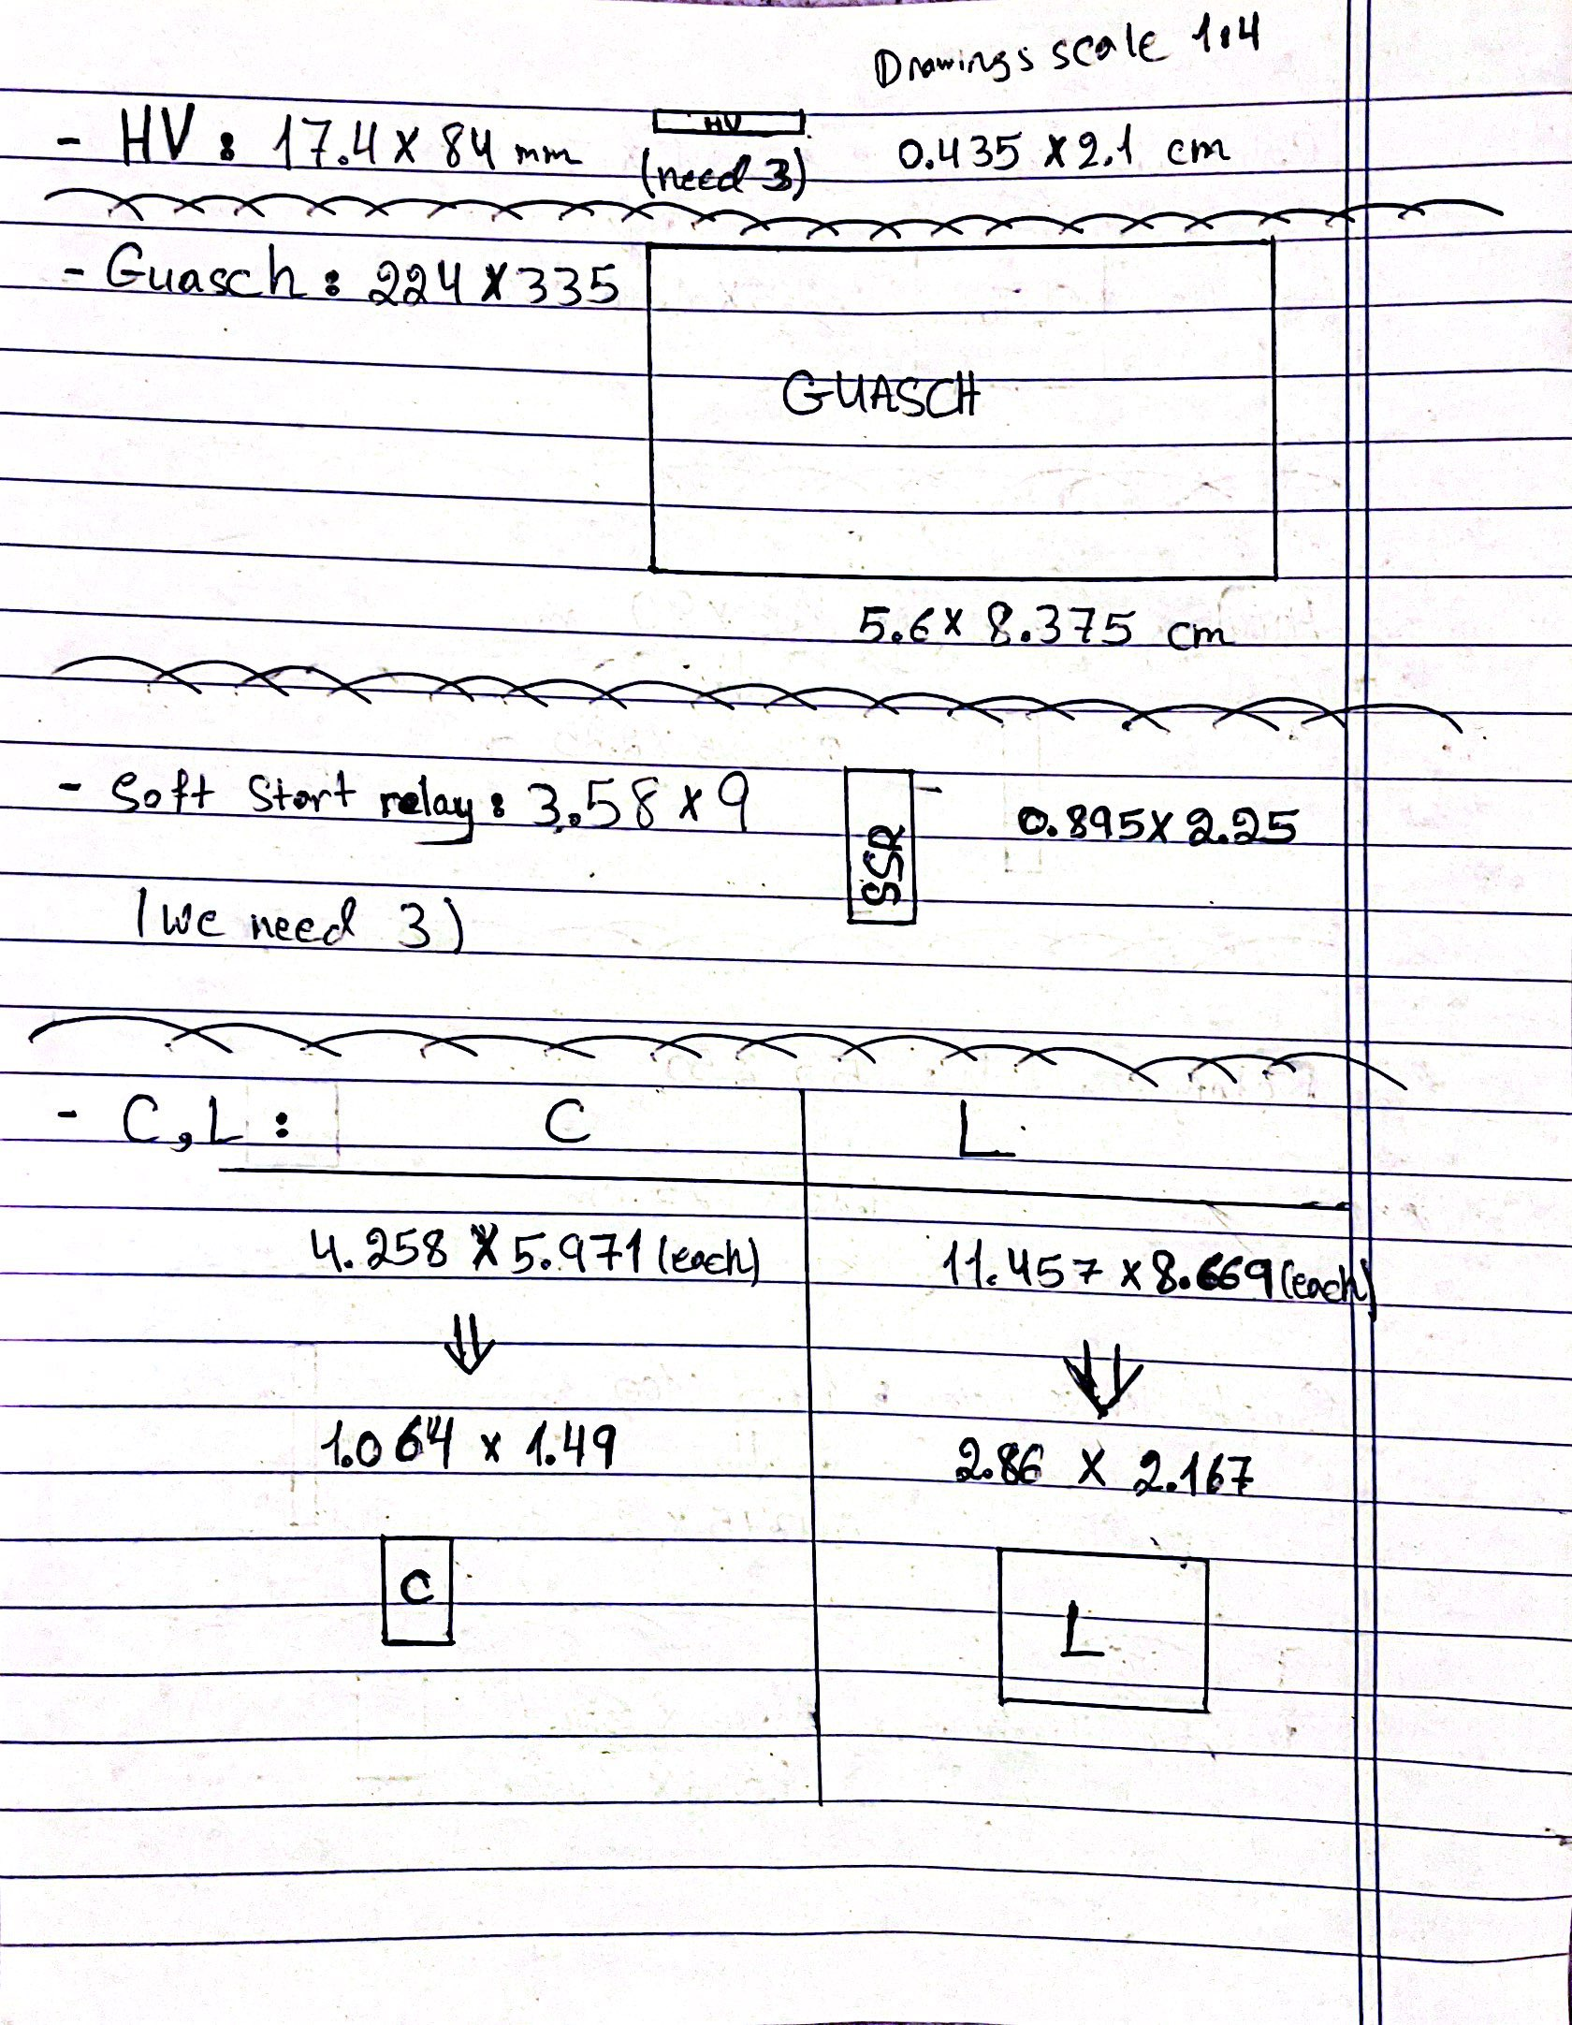

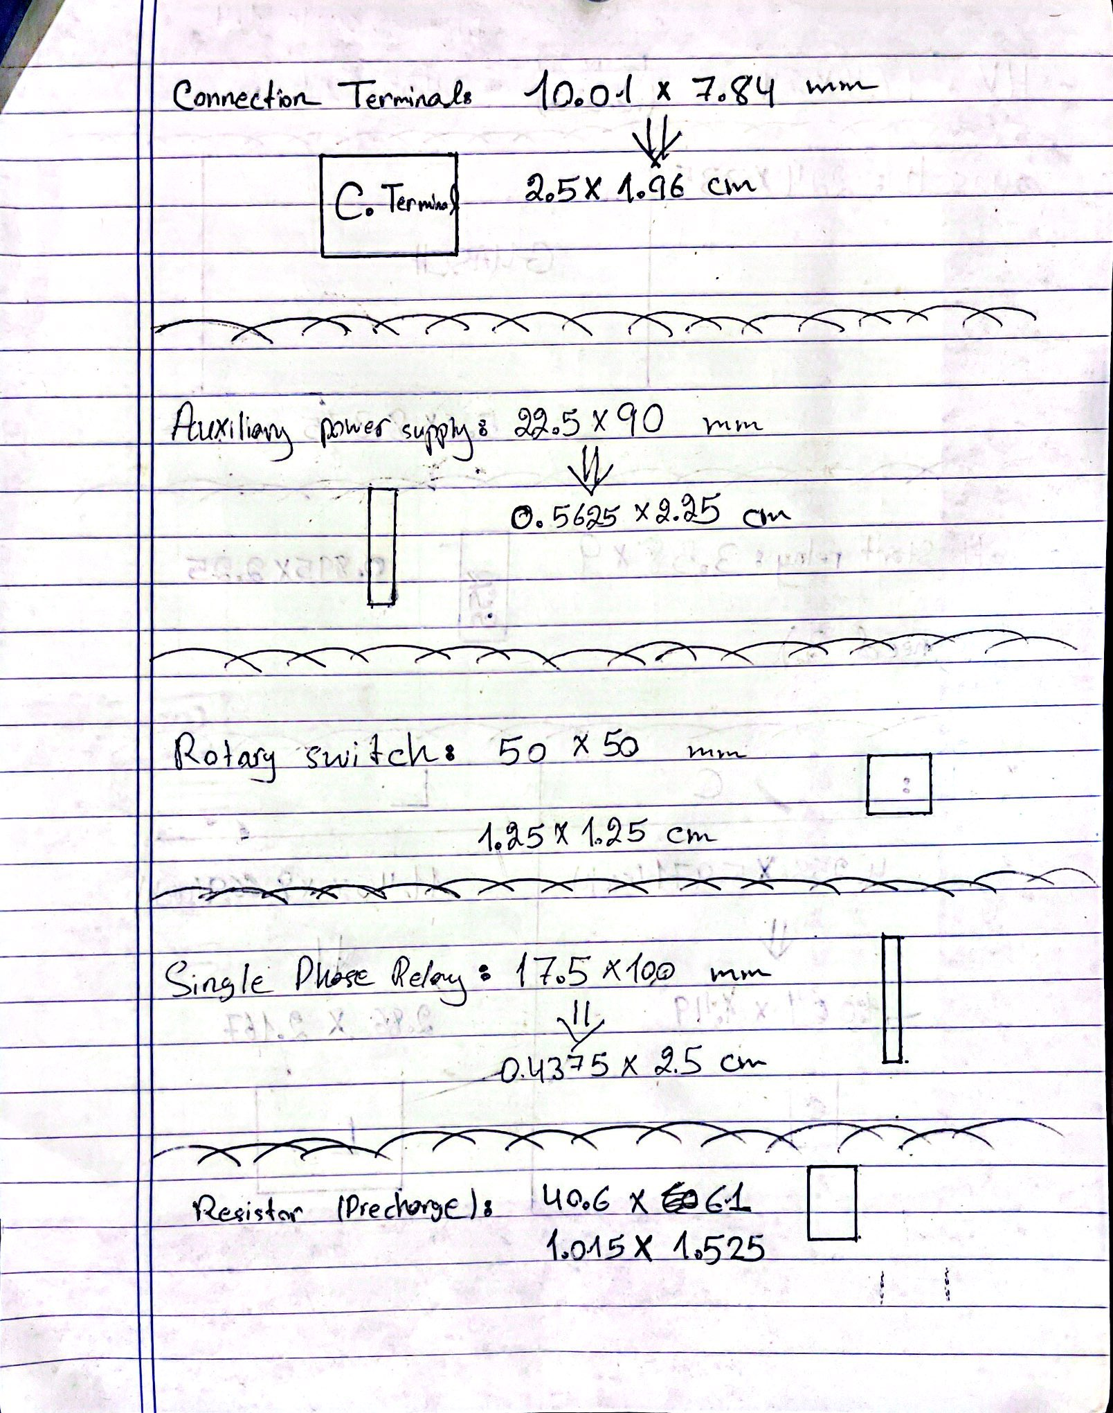

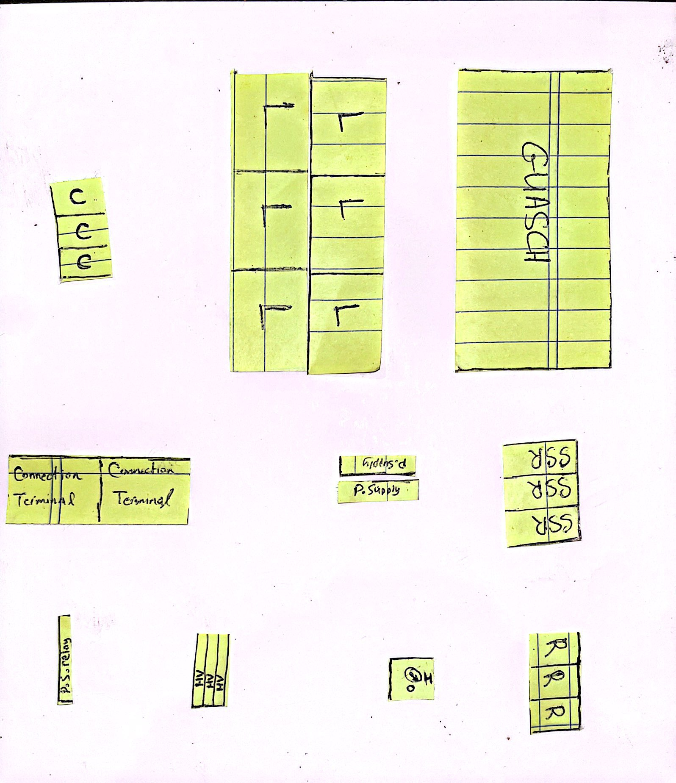page4image42611712

Soft-start relay

Connection terminals

Manual switch

Power supply

Circuit breaker

Power supply relay

We marked with the number “1” the same corner, looking at it from top and from bottom.

